PROJECTDOCUMENTATION

ProjectTitle

RhythmicTunes:YourMelodicCompanion

1. Introduction

TeamID:NM2025TMID47868

TeamLeader:GNANAPPRAKASAM K([gnanapprakasam17@gmail.com](mailto:gnanapprakasam17@gmail.com) )

Team Members:

1.PRADHEEP L([pradeepsakthi575@gmail.com](mailto:pradeepsakthi575@gmail.com) )

2.RAGHUNATH V([raghu89031@gmail.com](mailto:raghu89031@gmail.com) )

3.SUDHARSAN M

([sudharsonsudharson1717@gmail.com](mailto:sudharsonsudharson1717@gmail.com) )

Roles and Responsibilities TeamLeader:

Gnanapprakasam k

Overseesprojectprogressandtaskallocation.

Coordinatesteamcommunicationandfinalintegration. Ensures timely submission and quality of deliverables.

TeamMember:

Pradheep L

DesignsanddevelopsUI/UX.

Implementsmusicdashboardandplaylistfeatures. Integrates frontend with backend APIs.

TeamMember:

Raghunath V

Develops server-side logic and database. CreatesAPIsforuser,music,andplaylists. Manages authentication and data flow.

TeamMember:

Sudharsan M

Conductstestinganddebugging.

Ensures application quality and performance. Preparesresearchinputsanddocumentation.

1. ProjectOverview Purpose:

RhythmicTunesisaninteractivemusiccompanionapplication

designedtohelpusers discover,organize,andenjoymusicseamlessly.Itaims to enhance the listening experience by offeringcurated playlists, personalized recommendations, and interactive music-based features.

Features:

* + Musicstreamingand playback
  + Personalizedplaylistrecommendations
  + Mood-basedsongsuggestions
  + Userprofilemanagement
  + Searchandfilterbygenre,artist,ormood
  + Adminpanelforcontentmanagement

1. Architecture Frontend:

React.jswithTailwindCSSandMaterialUI Backend:

Node.jswithExpress.jsforserver-sidelogic Database:

MongoDBforstoringuserdata

1. SetupInstructions Prerequisites:

Node.js,MongoDB,Git,React.js,Express.js,VisualStudioCode

InstallationSteps:

#Clonethe repository

#Installclientdependencies→cdclient&&npminstall

#Installserverdependencies→cd../server&&npminstall

1. Folder Structure RhythmicTunes/|--client/

#React--frontend|nnncomponents/|nnnpages/|-- server/

#Node.js--backend|nnnroutes/|nnnmodels/|nnncontrollers/

1. RunningtheApplication

Frontend: cd client && npm start Backend: cd server && npm start Access:Visit[http://localhost:3000](http://localhost:3000/)

1. APIDocumentation

User: /api/user/register, /api/user/login Music/Playlists: /api/music/search, /api/music/ recommend,/api/playlists/create, /api/playlists/:id Admin: /api/admin/manage

1. Authentication

JWT-basedauthenticationforsecurelogin.Middlewaretoprotectuser and admin routes.

1. UserInterface

Landing Page MusicDashboard

PlaylistManagementPage Admin Panel

NowPlayingPage

1. Testing

Manualtestingduringmilestones.Tools:Postman,ChromeDevTools.

1. Screenshotsor Demo

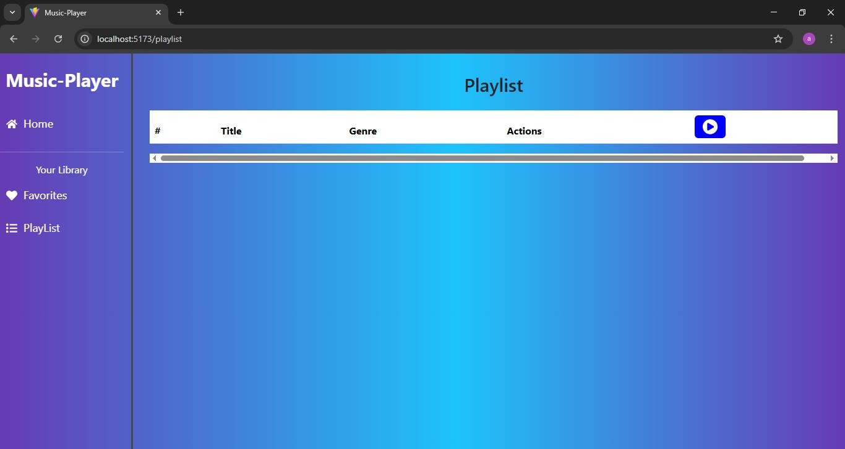

1. KnownIssues

* IntegrationwithexternalmusicAPIsunderprogress.
* Limitedofflinesupport.

1. FutureEnhancements

* AI-basedmoodrecognitionforautomaticplaylistgeneration
* Voicecommandintegrationforhands-freemusiccontrol
* Cross-platformmobileappversion